Comparing Multipliers

- Vedic Multiplier :-
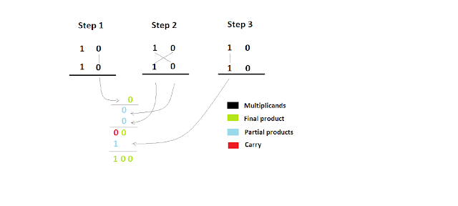
The figure shows how to multiply two 2 bit numbers using Urdhva Triyakbhyam Sutra. Now with this logic we have to convert it to a equivalent hardware. Two bit multiplication is equivalent to a “and” gate so the first part is over. Next part is to add two bits which is nothing but a half adder and for our logic we need two half adders.

- So using 2 bit vedic multiplier we can get 4 bit vedic multiplier, we use to get 8 bit vedic multiplier & so on.

Design of 32 bit Vedic Multiplier :
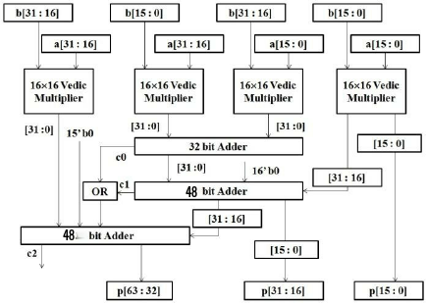

- Wallace Tree Multiplier :-
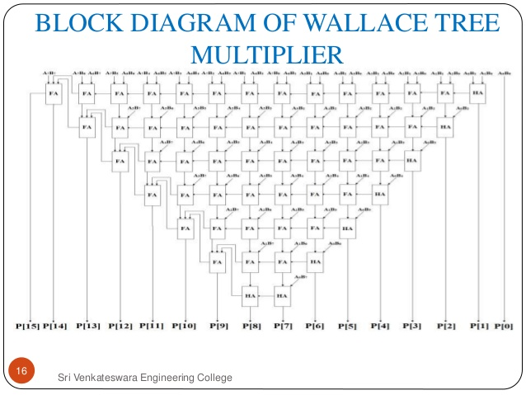
At first we code a 8 bit wallace tree multiplier with the help of half-adders and full-adders .

- Now with the help 8 bit wallace tree multiplier we code 16 bit wallace tree multiplier and using it we make 32 bit wallace tree multiplier.

- The Gate Delays of Multipliers :-

- Vedic Multiplier-
Gate Delay of 42ns.\
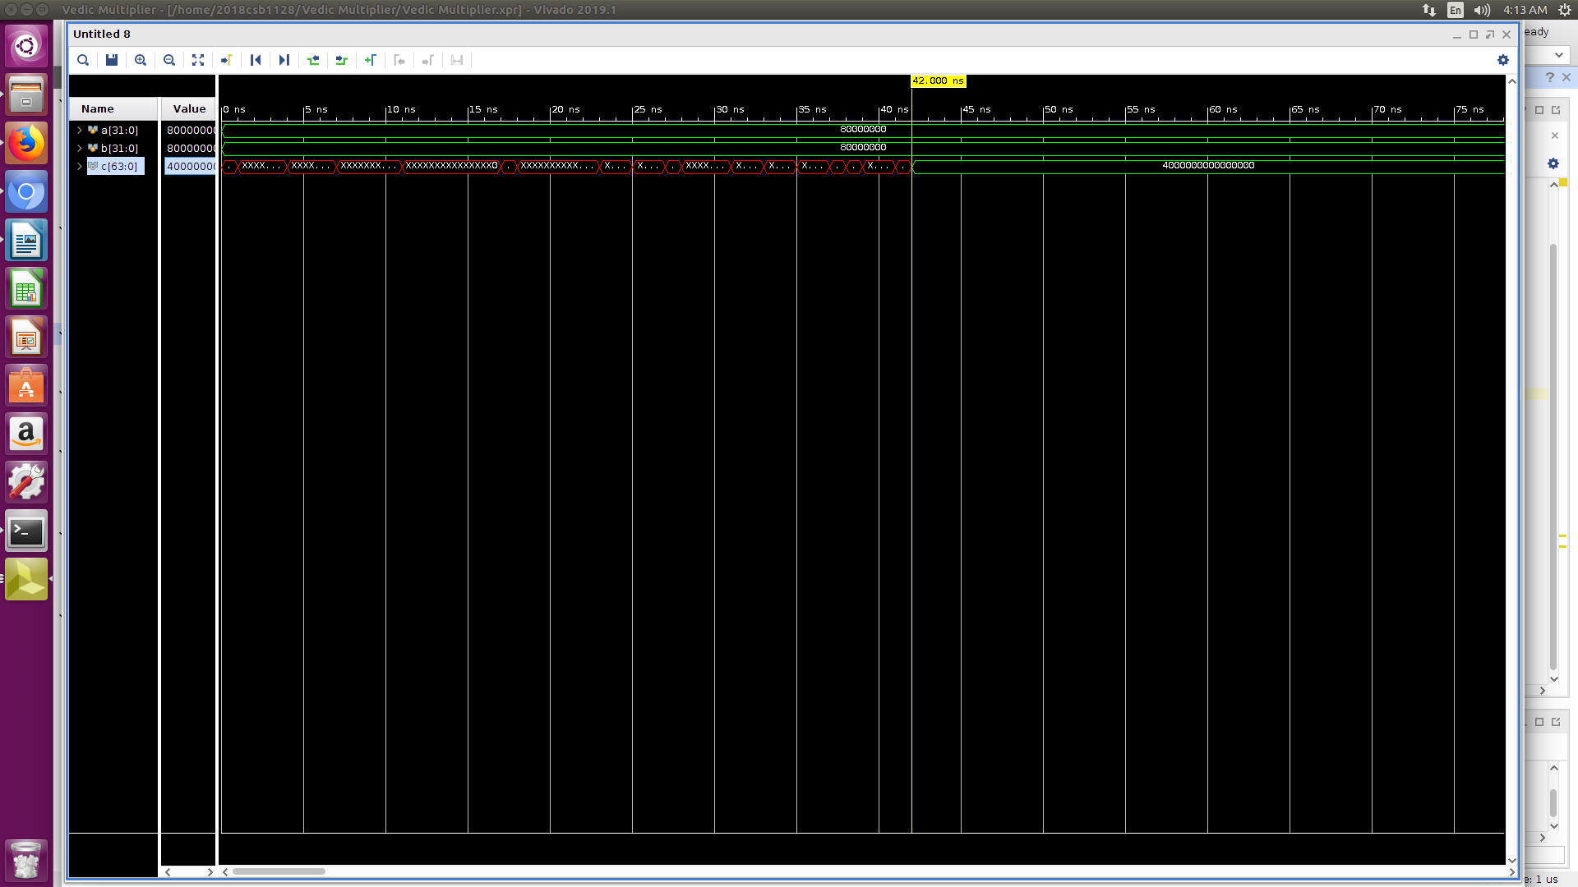

- Wallace Multipliers :
Gate Delay of 44ns.
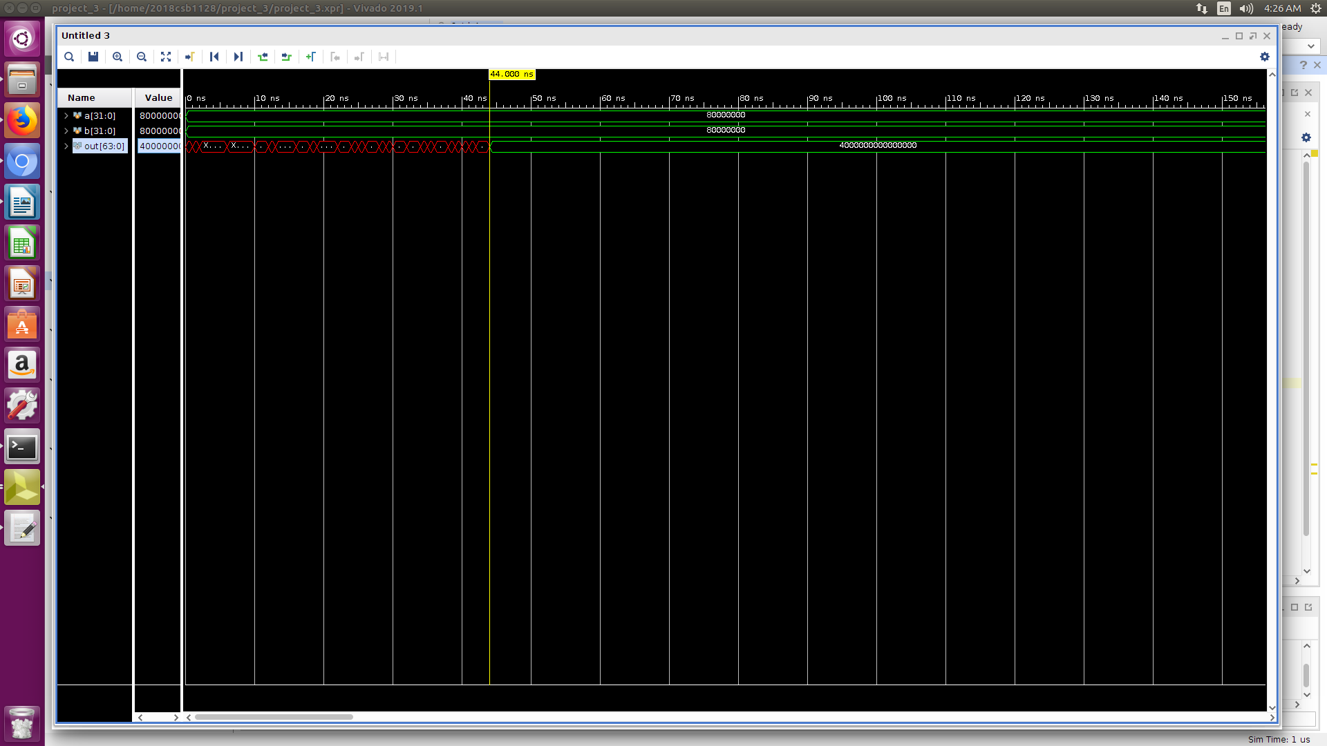

- Classic Multiplier :
Gate Delay of 76ns.
